Scatterplot of simulated random errors

based on the cluster status at the end of the 40 Markov chains

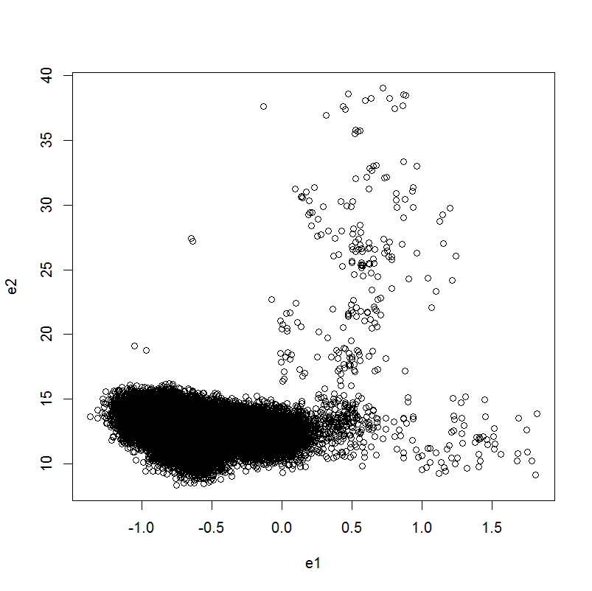

Contour density plot

